**DAILY ONLINE ACTIVITIES SUMMARY**

|  |  |  |  |  |  |  |  |  |
| --- | --- | --- | --- | --- | --- | --- | --- | --- |
| **Date:** | 06-06-2020 | | | | | **Name:** | Anvitha H M | |
| **Sem & Sec** | 4th ‘A’ | | | | | **USN:** | 4AL18CS010 | |
| **Online Test Summary** | | | | | | | | |
| **Subject** | | Data communication. | | | | | | |
| **Max. Marks** | | 30 | | **Score** | | | 23 | |
| **Certification Course Summary** | | | | | | | | |
| **Course** | Front end development - HTML | | | | | | | |
| **Certificate Provider** | | | Great learning academy | | **Duration** | | | 3.5 hours |
| **Coding Challenges** | | | | | | | | |
| **Problem Statement:**  1. Java program to sort an array of size N containing 0’s, 1’s, 2’s, in ascending order.  2. C program to rotate an array by N position. | | | | | | | | |
| **Status:** Executed | | | | | | | | |
| **Uploaded the report in Github** | | | | | YES | | | |
| **If yes Repository name** | | | | | <https://github.com/anvithahm/LOCKdown-coding> | | | |
| **Uploaded the report in slack** | | | | | Yes | | | |

**Online test:** DC test was scheduled from 009:30am to 10:15am. The portion for the IA was 5th module there were 30 questions and the time assigned was 45minutes the questions were MCQ type. I scored 23/30.

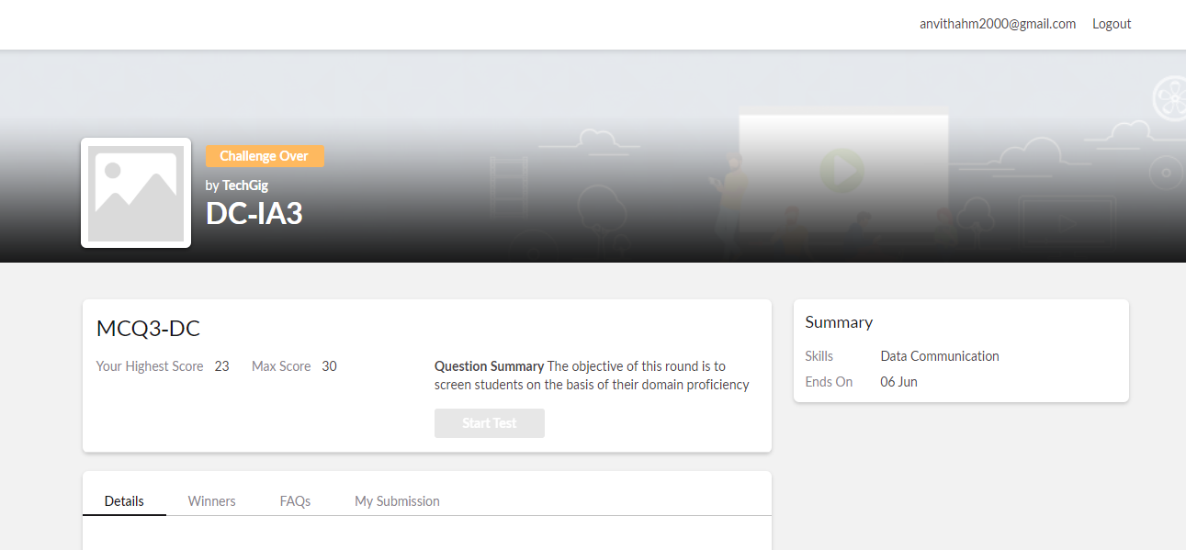

**Certification course:**

Front end development – HMTL

The course included span tag, block level elements, inline elements and relationship between elements with some assignments and quiz of it.

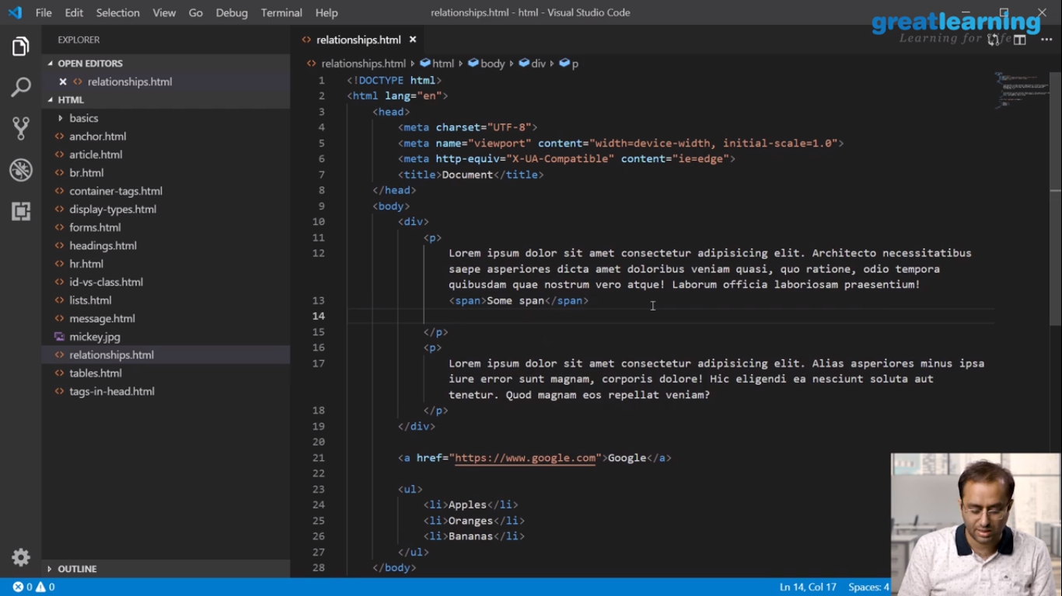

Online coding challenge

The programing statements of the day is 1. Java program to sort an array of size N containing 0’s, 1’s, 2’s, in ascending order.

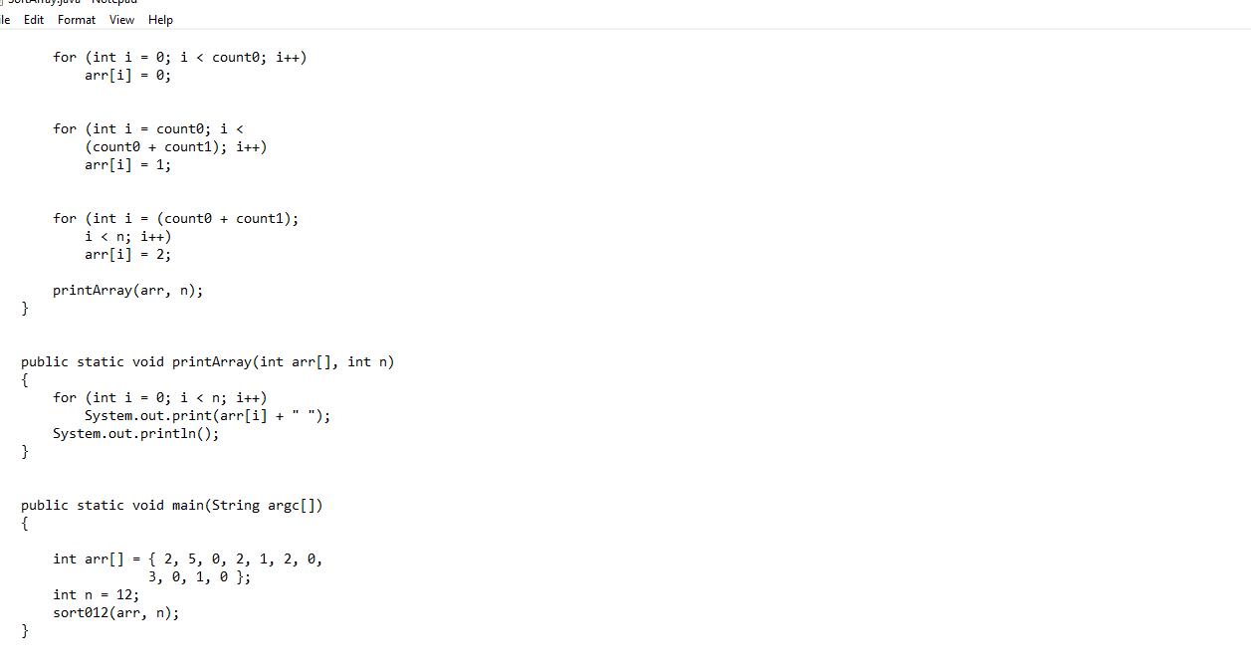 2. C program to rotate an array by N position.

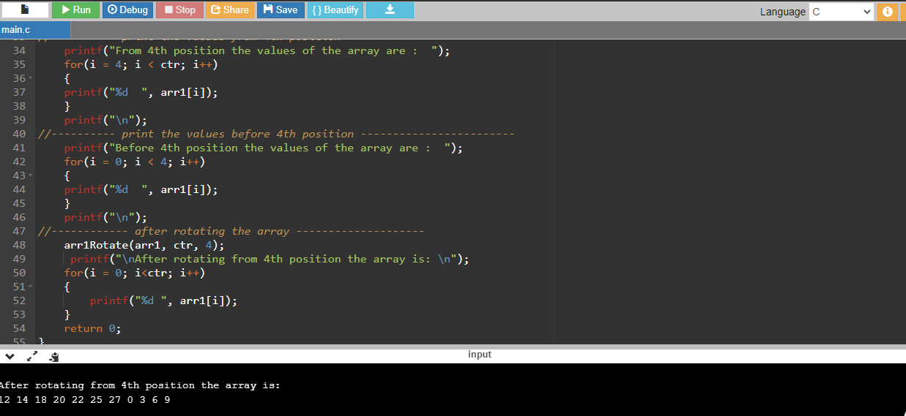

Solution: Executed and uploaded in Github repository.

Link: <https://github.com/alvas-education-foundation/Anvitha-H-M>